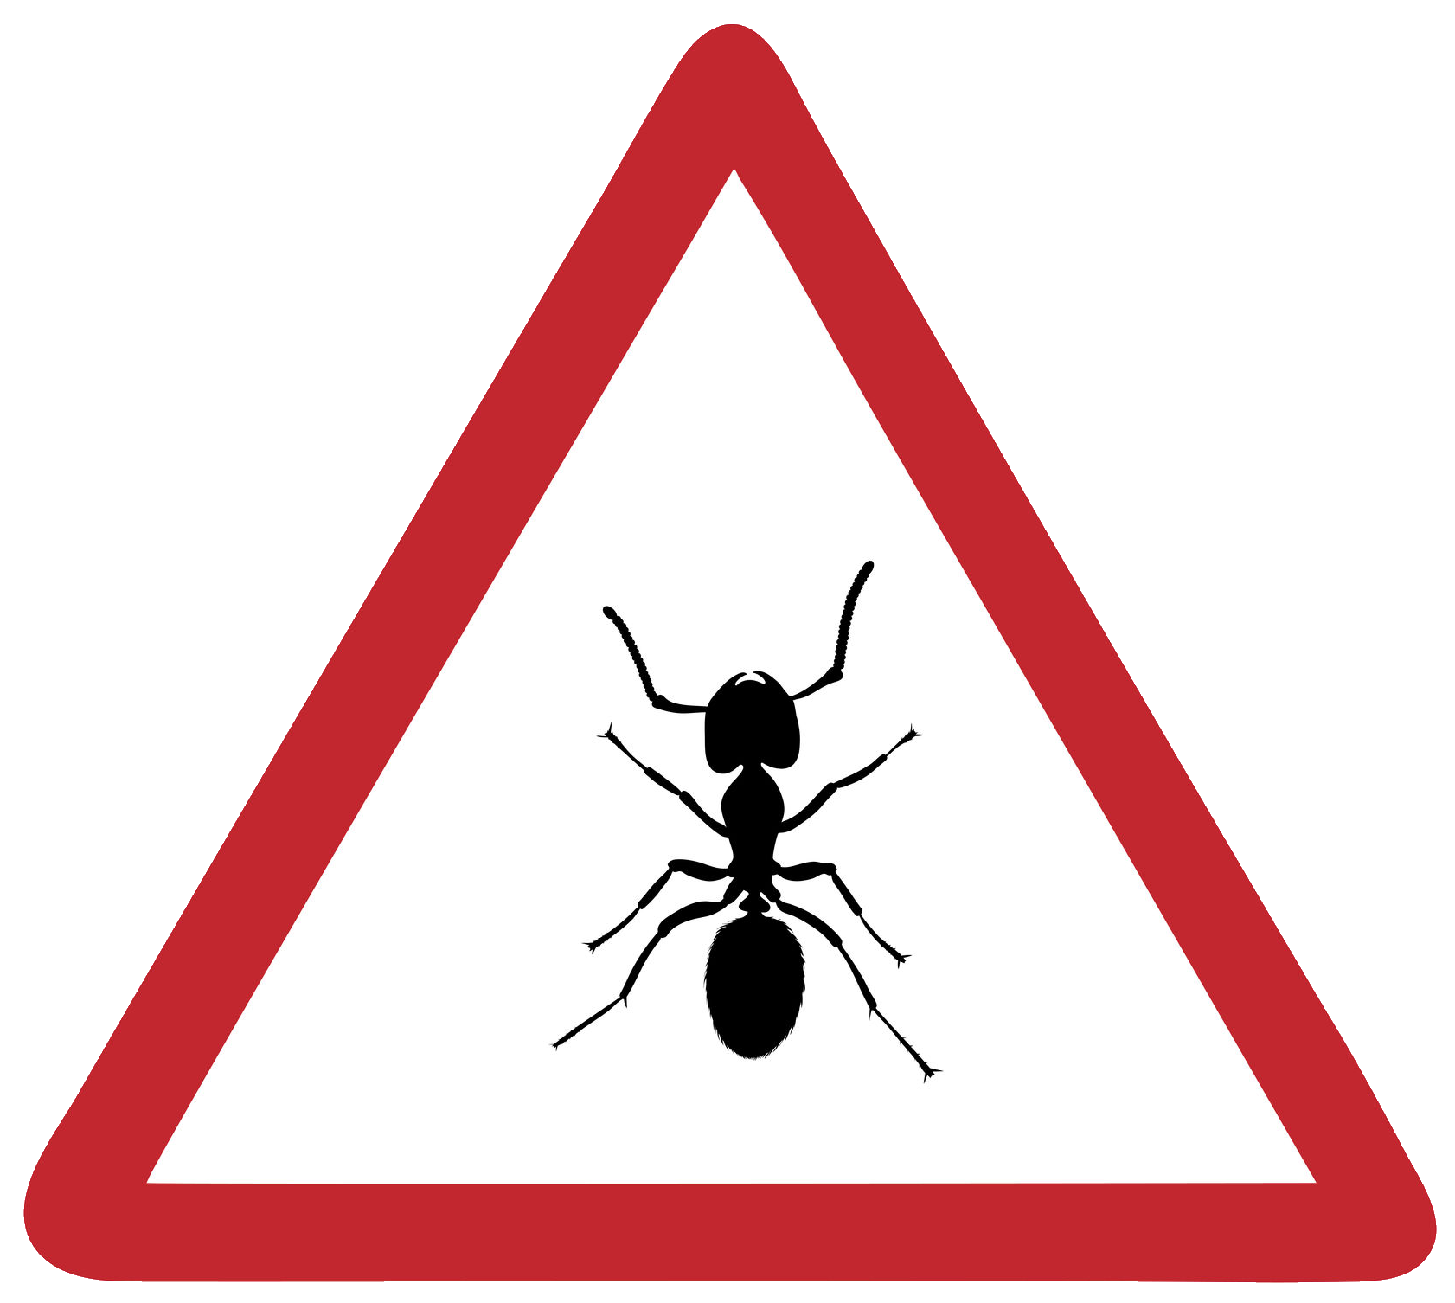 Ant Simulation

Programming Tasks (Extension)

Extension 1
In the standard simulation, ants will continue to follow a pheromone trail towards a food source, even when that food source has been exhausted. Introduce a second pheromone, “food source exhausted”, to the Ant class. When an ant finds that the food source has less than 10% remaining, that ant should lay down the new pheromone rather than the standard pheromone as it returns to the nest. The new “food source exhausted” pheromone should quadruple the decay level of the standard pheromone to help erase the path more quickly.

Extension 2
In the standard simulation it is possible for the Queen ant to be culled at random. Introduce a new method into the Nest class which detects if a Queen has not been present for three stages and promotes a normal WorkerAnt to a new Queen.

Extension 3
Introduce the concept of a soldier ant which can spray formic acid. Create a new SoldierAnt class which moves using the normal random movement around the simulation world. At each stage the soldier ant should review all of its neighbouring cells. If the soldier ant finds an ant or ants that belong(s) to a different nest, it should spray formic acid towards that cell, killing all of the ants in that cell.

Extension 4
Introduce a “message-passing” system whereby ants can leave messages for each other by bumping heads as they move past each other. Modify the Cell class to include the concept of “food quality” on a scale of 1–5 (1 being poor, 5 being highly nutritious). As ants pass each other taking food back to the nest, the returning ant, carrying food, “bumps heads” with other ants to inform them of the quality of the food source. Modify the ChooseCellToMoveTo method to use this information as additional weighting for deciding if an ant will follow the pheromone trail.

Extension 5
Introduce the concept that a nest can have a maximum of 30 ants belonging to it. Once that capacity has been reached, create a new Queen ant which leaves the nest and moves at random through the simulation to create a new nest. Two nests cannot be in neighbouring cells.

Extension 6
Introduce two new options, 6 and 7, to the main menu to give the user the ability to save and reload a simulation using a CSV file.

Extension 7
Implement a dictionary data structure into the WorkerAnt class which stores the location of any food source found and how much food there is. At each stage, use the strength of the pheromone trail leading to the food source to make a guess at how many ants have visited the food source and therefore how much food is being consumed per stage, and update the dictionary. Use this within the ChooseCellToMoveTo method as additional weighting for selecting whether to move along a pheromone trail back to a food source.

Extension 8
Implement the A* algorithm for a worker ant to find the shortest path back to its nest when carrying food. Use Manhattan distance as the heuristic.

Extension 9
Modify the Cell class to allow different types of food – for example, food and water. Introduce the same concept to the Nest class to monitor how much has been collected by the worker ants. Modify the WorkerAnt class so that an ant won’t collect a particular food source if there is already plenty in the nest.

Extension 10
Introduce polydomous colonies which can have multiple nests. Track shared resources to allow ants to deposit food at nests within their colony rather than just at one specific nest. If an ant gets to a nest and there is already plenty of food, then it should go to another nest.

Extension 11
Modify the Nest class to create a new method called ShareFoodWithNearbyNests which allows ants in one nest to take food to the ants in another nest if it is running low.

Extension 12
Implement Tandem Running by implementing new LeadAnt and FollowerAnt classes. Once food has been found, instantiate two ants in the nest: one “Lead” and one “Follow”. The “Follow” doesn’t follow the pheromone, instead moving randomly, but has double the food-carrying capacity. The “Lead” follows the pheromone trail, moving slowly (one cell per two stages). At each stage it should check to see if the follower is within one cell distance. If not, it waits. The follower ant has a 90% chance of moving towards the leader’s current position. It stops if already adjacent. When both ants reach the food cell, the follower ant picks up the food and takes it back to the nest.

Extension 13
Introduce the concept of “most food per unit of time” (stage). Modify the Cell class to restrict a cell to allowing only three ants present at any time. Introduce a new Bridge class which can be placed into a cell which has a capacity of 10 ants present at any time. Add a new option 6 to the main menu to allow the user to place bridges into the simulation at any location except the nest. Add a new option 7 to the main menu to allow the user to place food into cells. Demonstrate ants ignoring a large amount of food being placed in a cell at a location which can’t be navigated to using bridges in favour of a smaller amount of food that is easier to get to because overall the nest gains a greater amount of food per unit of time.

Extension 14
Introduce the concept of “unsociality” whereby a worker ant defects to a different nest if that nest has more food in it and therefore offers the ant a greater chance of survival.

Extension 15
Introduce the concept of “nutritional value” in a food source. Once a unit of food has been brought back to the nest, it is assessed by the ants in the nest. If it is lower than other food sources they have looked at, a ReviewerAnt follows the pheromone trail out to the food source, removing it.

